- Deliverables:
  - Pipeline DAG/script showcasing task automation
  - Screenshots of successful pipeline runs in the orchestration tool
  - Logs or monitoring dashboard screenshots

End-to-end Pipeline run in progress
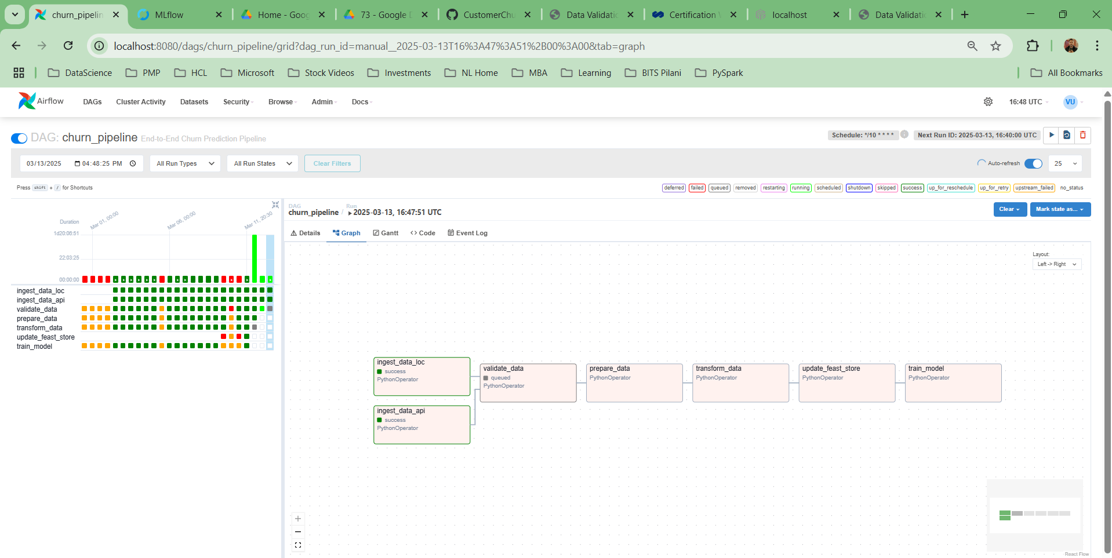

Log from Airflow for data_ingestion
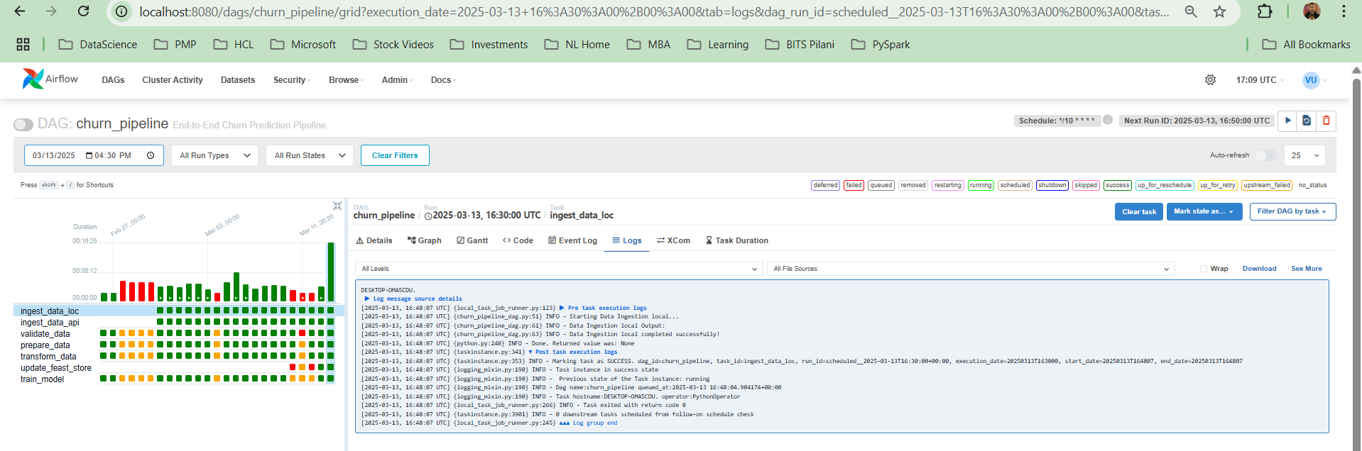

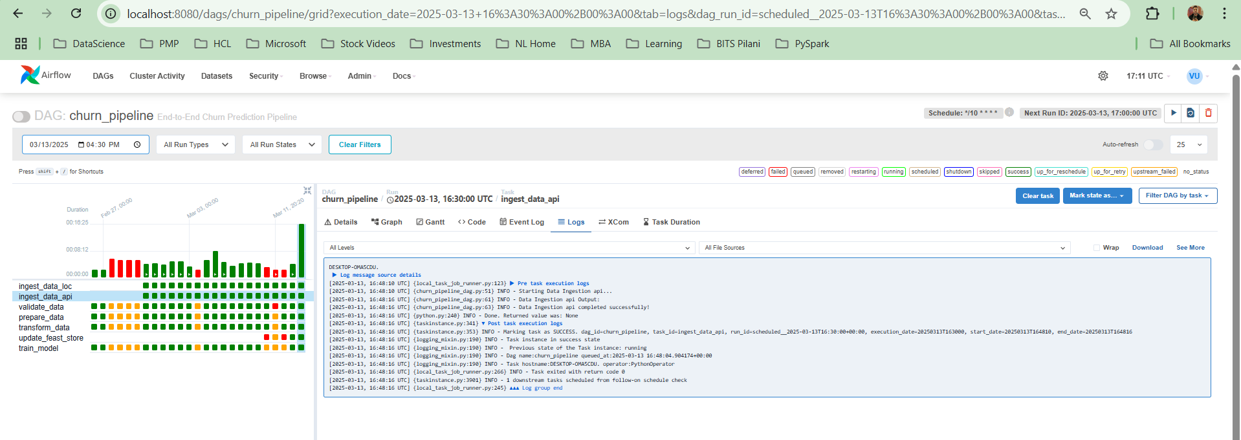

Log from Airflow for data_preprocessing
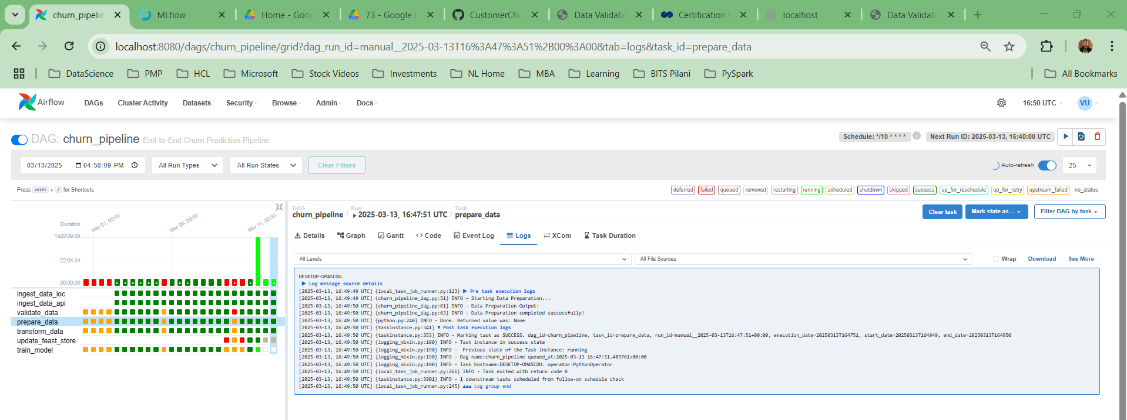

Log from Airflow for model building
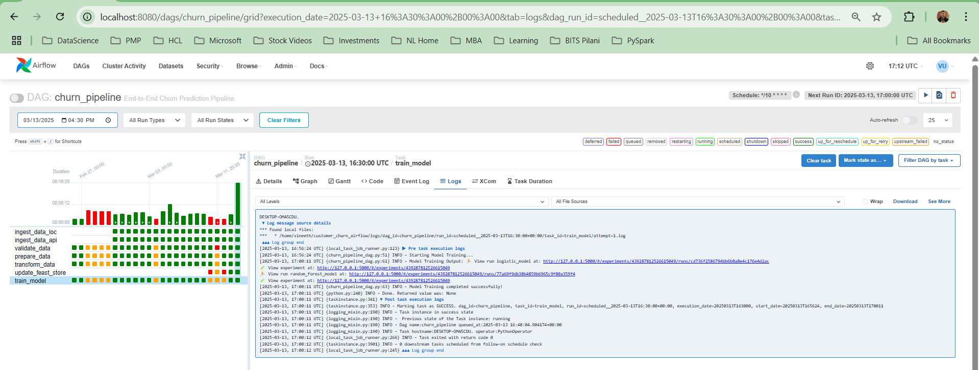

We can see it is scheduled every 10 mins(for demonstrations) and the next run is already queued for after 10 mins, later the cron will be updated to run every hour (schedule_interval='0 * * * *') in the DAG script

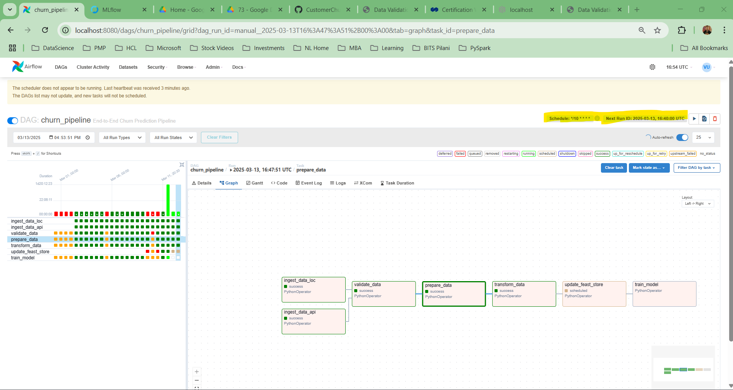

Now we can see multiple successful dag run

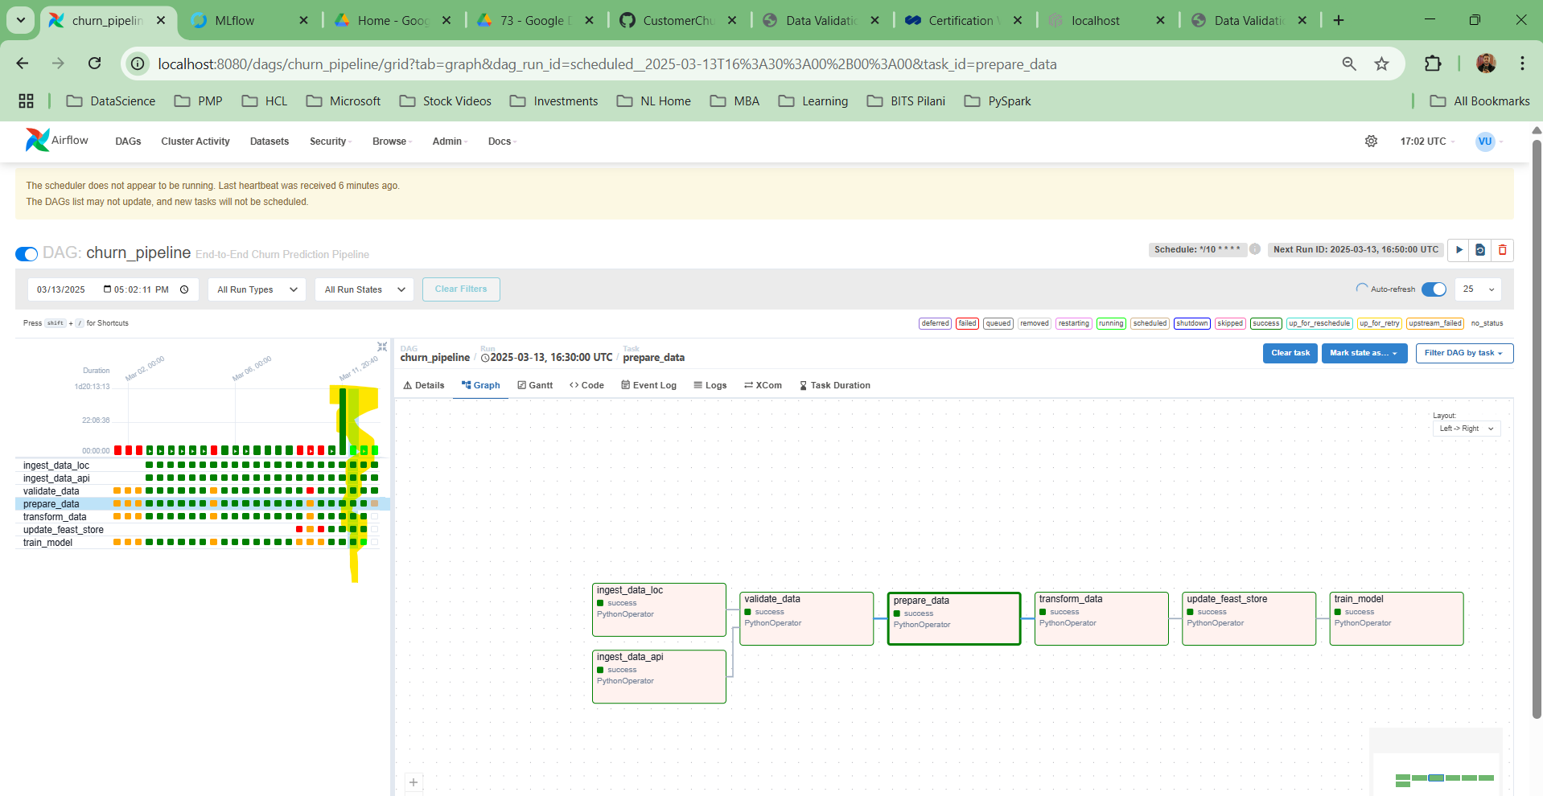

Event log for entire flow
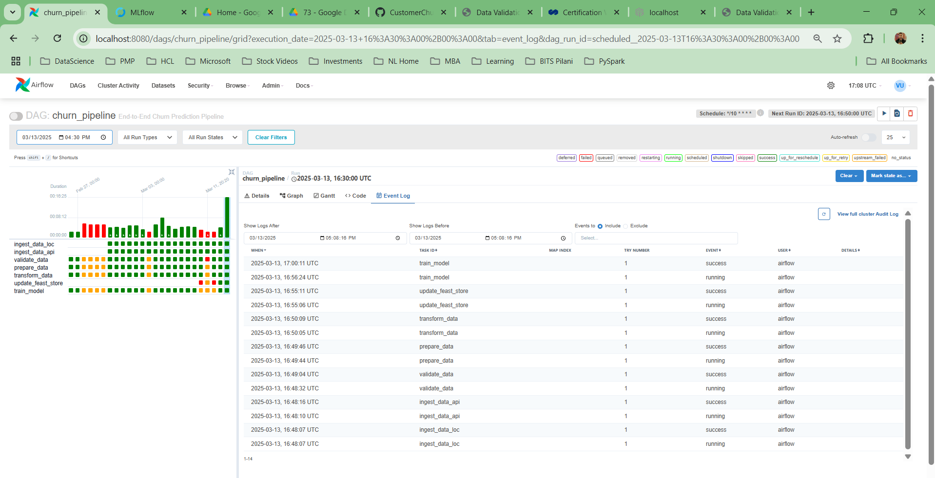

List of dag runs
